



UCCD1203 DATABASE DEVELOPMENT AND APPLICATIONS

Assignment June 2023

Group No: 60

|  |  |  |  |  |  |
| --- | --- | --- | --- | --- | --- |
| **No** | **Student ID** | **Name** | **Program** | **Lecture**  **Group** | **Signature** |
| **1.** | **2105034** | **Desmond Ho Jia Shen** | **CS** | **L3** |  |
| **2.** | **2003834** | **Joseph Lau Yi Zhe** | **CS** | **L3** |  |
| **3.** | **2103887** | **Ong Yi Sheng** | **CS** | **L3** |  |
| **4.** | **2206802** | **Tharini A/P Vijesh Kumar** | **CS** | **L3** |  |

Marking Section:

|  |  |
| --- | --- |
| **Section** | **Marks** |
| **Part A** |  |
| **Part B** |  |
| **TOTAL** |  |

## MARKING SCHEME

|  |  |
| --- | --- |
| **Scholarship Application Database Case Study** | |
| **Checklist for Part A – Database Design (5%)** | |
| 1. **Introduction (5 marks)**  Describe the system overview, the 3 main objectives of this project, and the list of database users. |  |
| 2. **ER model (15 marks)**  You are required to design an ER diagram for the case study given, identify entities, identify relationships, identify associate attributes, and determine keys. Check the ERD with the requirements stated in the case. Resolve all the many-many relationships. |  |
| 3. **Business Rule Requirements (10 marks)**  Identify the business rule involved based on the ERD. Please include any assumptions that you make. |  |
| 4. **Report (5 marks)**  Submit your report with proper technical writing skills (cover page, headers & footers, page numbering, headings, section numbering, proper fonts, spell checked, proper alignments, spacing, marking scheme, table of contents etc). |  |
| **SUBTOTAL:** | **/35** |

|  |  |
| --- | --- |
| **Checklist for Part B – The Implementation of Database using Microsoft Access (5%)** | |
| 1. **Tables and records (15 marks)**  Create all the relations in the ERD and insert the necessary records. (at least 10 records per table except for scholarship provider records) |  |
| 2. **Queries (15 marks)**  Create 3 useful queries based on the given case study and include the corresponding SQL command. Explain the purpose of each query. |  |
| 3. **Forms (15 marks)**  Create 3 useful forms based on the given case study. You may use subform(s). Explain the purpose of each form. Include colours/images to make your form look interesting. |  |
| 4. **Reports (15 marks)**  Create 3 useful reports based on the given case study. Explain the purpose of each report. Design your reports so that it will look proper and easy to understand. |  |
| 5. **Switchboard (5 marks)**  Create a switchboard that includes all the tables, forms, queries and reports. Make sure the switchboard can **start automatically** when the database is open and include the **exit button** to exclude the user from the database. |  |
| **SUBTOTAL:** | **/65** |

**TABLE OF CONTENTS**

|  |  |
| --- | --- |
| **FRONT PAGE** | **i** |
| **MARKING SCHEME** | **ii** |
| **TABLE OF CONTENTS** | **iv** |
| **LIST OF FIGURES** | **v** |
| **LIST OF TABLES** | **vi** |
|  |  |
| **CHAPTER 1 PROJECT BACKGROUND** |  |
| 1.1 System Overview | 1 |
| 1.2 Project Objectives | 1 |
| 1.3 Target Database User | 1 |
|  |  |
| **CHAPTER 2 DATABASE DESIGN** |  |
| 2.1 List of entities and attributes | 3 |
| 2.2 Entity Relationship Diagram (ERD) | 4 |
| 2.3 Assumptions and Business Rules | 5 |
|  |  |
| **CHAPTER 3 DATABASE DEVELOPMENT** |  |
| 3.1 List of tables |  |
| 3.1.1 Data Dictionary and Table Records | 7 |
| 3.2 Switchboard | 14 |
|  |  |
| **CHAPTER 4 DATABASE OBJECTS** |  |
| 4.1 Queries | 16 |
| 4.2 Forms | 19 |
| 4.3 Reports | 22 |
|  |  |
| **CHAPTER 5 CONCLUSION** |  |
| 5.1 System Weaknesses | 25 |
| 5.2 Future Improvement | 26 |

## LIST OF FIGURES

|  |  |  |
| --- | --- | --- |
| **Figure Number** | **Title** | **Page** |
| Figure 2.1 | Entity Relationship Diagram (ERD) | 4 |
| Figure 3.2.1 | Main Menu Switchboard | 14 |
| Figure 3.2.2 | Student Menu Switchboard | 14 |
| Figure 3.2.3 | Scholarship Provider Menu Switchboard | 15 |
| Figure 3.2.4 | Application Menu Switchboard | 15 |
| Figure 4.1.1 | Sample of View AppStatus | 16 |
| Figure 4.1.2 | Sample of View Recommender Query | 17 |
| Figure 4.1.3 | Sample of View Result Query | 18 |
| Figure 4.2.1 | Sample of Application form | 19 |
| Figure 4.2.2 | Sample of Scholarship Provider Form | 20 |
| Figure 4.2.3 | Sample of Student Info Form | 21 |
| Figure 4.3.1 | Sample of Recommendation Summary Report | 22 |
| Figure 4.3.2 | Sample of Scholarship Provider Report | 23 |
| Figure 4.3.2 | Sample of Student Application Summary | 24 |

**LIST OF TABLES**

|  |  |  |
| --- | --- | --- |
| **Table Number** | **Title** | **Page** |
| Table 2.1 | List of entities and attributes | 3 |
| Table 3.1.1 | Application Table | 7 |
| Table 3.1.2 | CommunityActivities Table | 8 |
| Table 3.1.3 | ExtracurricularActivities Table | 9 |
| Table 3.1.4 | Recommendation Table | 10 |
| Table 3.1.5 | ScholarshipProvider Table | 11 |
| Table 3.1.6 | SpmResult Table | 12 |
| Table 3.1.7 | Student Table | 13 |

# Chapter 1 Project Background

This database system is made to hold student information, such as SPM results, school names, and information about guardians. This project ensures that important information can be managed and stored efficiently.

The report's summary provides useful detail and makes use of the SPM student database. To present the database details about SPM leavers, this report has been divided into several sections, including Project Background, Database Design, Database Development, Database Objects, and Conclusions.

Project background, including the System Overview and Project objectives, which make clear the presence of this database system. It also includes the objectives, which provide clear and concise goals or aims that guide this project. They help define the desired outcomes and direction, facilitate the process of SPM students applying for scholarships, keep track of the status of their applications, and maintain other records by defining the desired outcomes and direction.

Database design shows the design of a list of entities and attributes, which is then used in designing the Entity Relationship Diagram (ERD). Apart from that, the Entity Relationship Diagram offers a simple and natural way to visualize the project's structure. The assumptions and business rules belong to the ERD and give it logic, limitations, and context.

In database development, the list of tables is created to have a better visualization of the relationship and the details. Hence, the Switchboard also allows users to navigate and access various functionalities or options. Database objects, including queries, forms, and reports, serve distinct purposes in managing and interacting with data.

Last but not least, the conclusion highlights the weaknesses of this project and suggests improvements for the future, which helps us understand how to make it the next time.

## System Overview

This project was created for SPM graduates and lets them store their student information in the data. For this reason, the scholarship providers are also kept in the database and can be connected to one or more applications so that they can choose the best scholarship providers. Additionally, this project included applications that had to be accompanied by two or more recommendations in order to identify the recommender information. As a result, the student must submit two or more applications to be recorded based on those applications. To view the status of applications submitted through the system, the system will pull out each applicant's individual results.

## Project Objectives

The objectives of this project are to store detailed information about the SPM leavers and scholarship providers, including their individual details, results, school name, guardian name, and many more attributes.

The project objectives are to investigate the relationship between all the entities that exist in this project to have a better understanding of the relationship and a simpler method to picture the project's structure.

## Target Database User

The targeted users for this database are the workers who come into contact with SPM leavers, and the scholarship providers who have stored their data in the applications.

# Chapter 2 Database Design

## List of entities and attributes

|  |  |
| --- | --- |
| **Entity** | **Attributes** |
| Student | StuID (PK), ResultID (FK), StuFN, StuLN, StuContact, StuDOB, CGPA, SchoolName, GuardianFN, GuardianLN, GuardianContact |
| Recommendation | RecID (PK), AppID (FK), RecFN, RecLN, RecJob, RecRelationship, RecContact, RecLetter |
| Application | AppID (PK), StuID (FK), ProviderID (FK), AppStatus, AppDate |
| SPMResult | ResultID (PK), Mathematics, Bahasa Melayu, English, Sejarah, Chemistry, Physics, Biology |
| CommunityActivities | CAID (PK), AppID (FK), CAName, CADate, CALocation, CAOrganizer, CADescription |
| ExtracurricularActivities | ECAID (PK), AppID (FK), ECAName, ECAPosition, ECALocation, ECAOrganizer, ECADescription |
| ScholarshipProvider | ProviderID (PK), ScholarshipName, EligibilityCriteria, AppDeadline, AwardAmount, ProviderContact, ScholarshipDetails |

**Table 2.1**

## Entity Relationship Diagram (ERD)

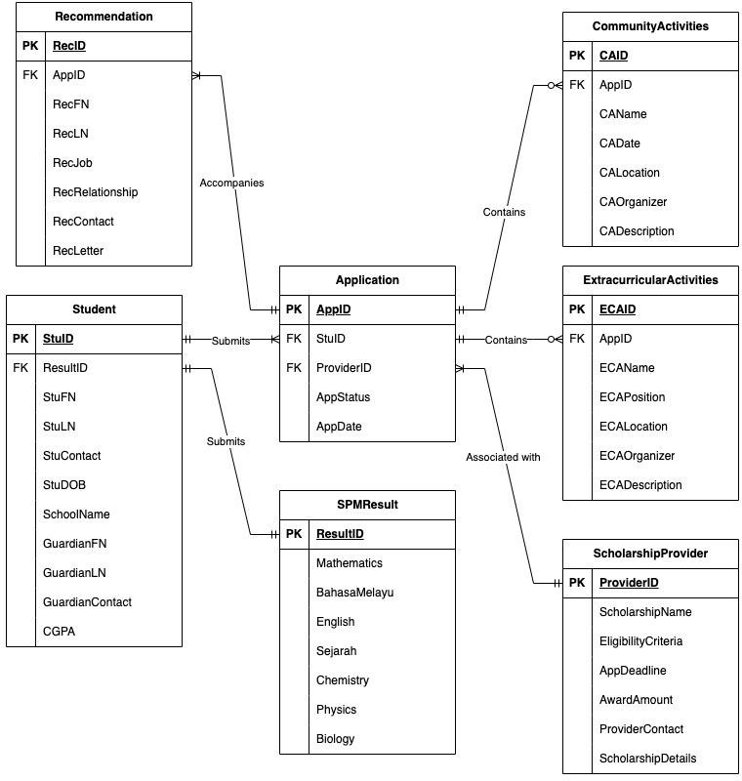

**Figure 2.1**

## Assumptions and Business Rules

#### Assumptions:

* Each application can be submitted by one and only one student.
* Each student has only one SPM result and therefore must submit one SPM result.
* Each SPM result can only be submitted by one student.
* Each recommendation can only accompany one application.
* Each application can contain no community activity or many community activities participated in by applicants.
* Each application can contain no extracurricular activity or many extracurricular activities participated in by applicants.
* Each extracurricular activity and community activity can only belong to one application, as the description of the activity will be different even though it has the same activity name.
* Each recommendation contains the recommender's name, job, relationship with the applicant, contact number, and recommendation letter.
* Each community activity includes its name, date, location, organizer, and a brief description of its goals and benefits.
* Each extracurricular activity includes its name, the applicant’s position as if involved in a committee, the location, an organizer, and a brief description of the achievements, such as competitions and awards.
* Each scholarship detail provides the terms and requirements for applying for the scholarship.
* Each student is required to provide one and only one guardian's information.

#### Business Rules:

* The SPM leavers, known as students, must be recognized in the system that stores student details, including SPM results, school names, and guardian information.
* The scholarship providers are stored in the database according to their scholarship name and details.
* Each scholarship provider can be associated with one or more applications, and each application is associated with only one scholarship provider.
* Each application must be accompanied by two or more recommendations, which will be used as the basis to identify the recommender in detail, especially the relationship between the applicant and the referees.
* The scholarship application is open once a year.
* The student can submit one or more applications, and the application will be recorded based on the individual application.
* Each application is expected to store the applicant's details, including application date, extracurricular activities, and community activities.
* The system will pull out the SPM result based on five important subjects, such as Mathematics, Bahasa Melayu, English, Sejarah, and any one of the science subjects.
* The student will be able to view the status of the application on the system.

# CHAPTER 3 Database Development

## Database Development

#### List of Tables

The tables involved in this project include those for the doctor, guardian, medication, patient, switchboard items, and treatment.

**Table 3.1.1: Application**

#### Data Dictionary

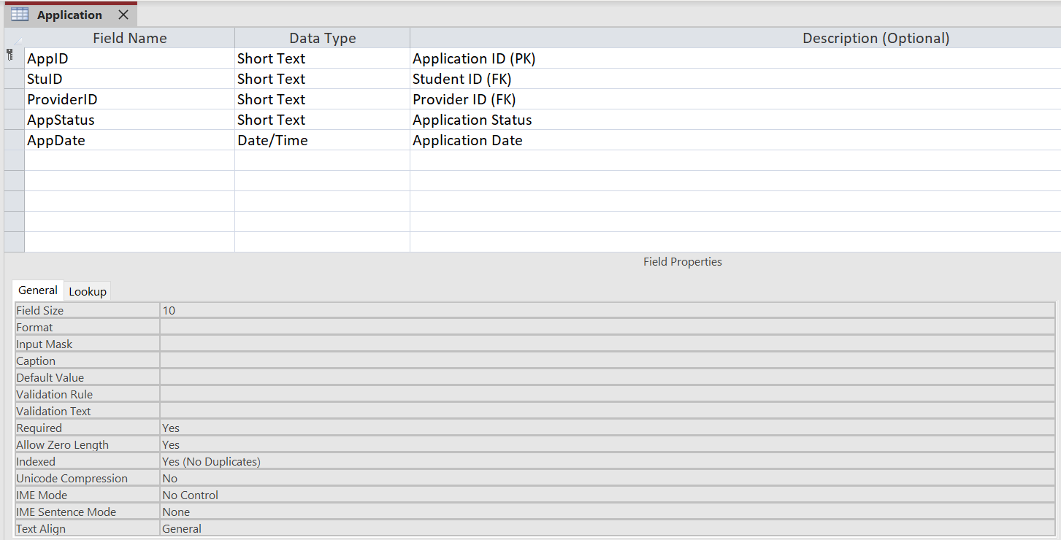

**Table Records**

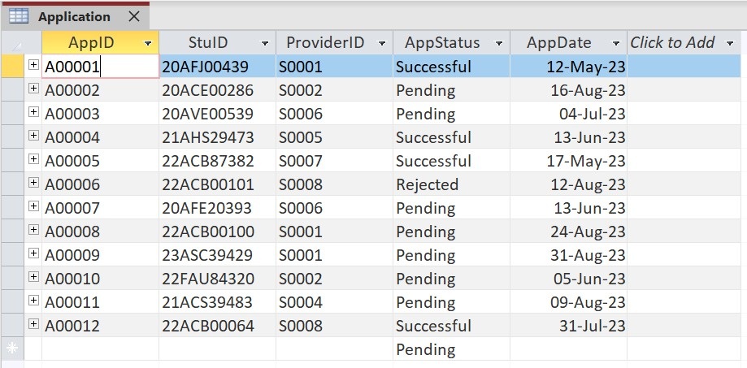

### Table 3.1.2: CommunityActivities

#### Data Dictionary

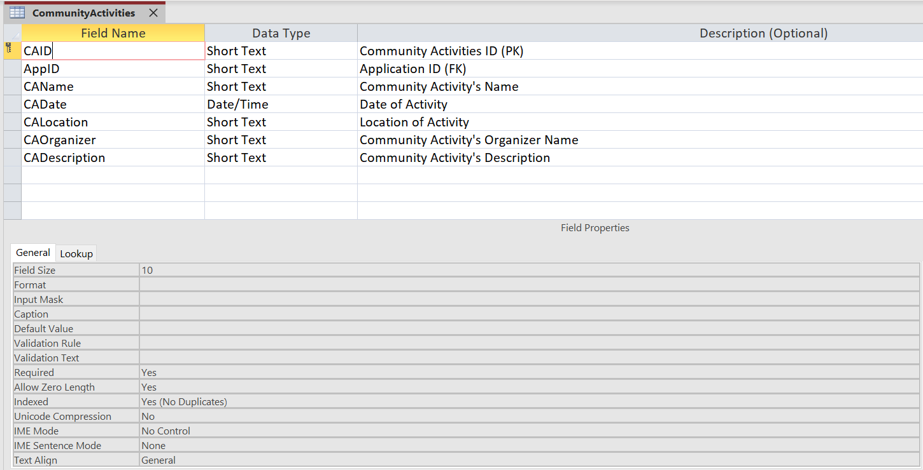

**Table Records**

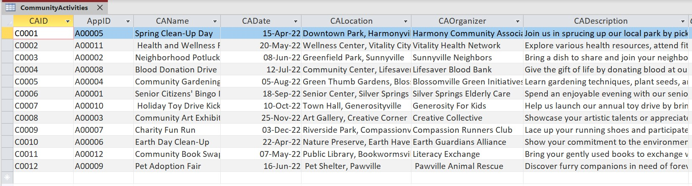

### Table 3.1.3: ExtracurricularActivities

#### Data Dictionary

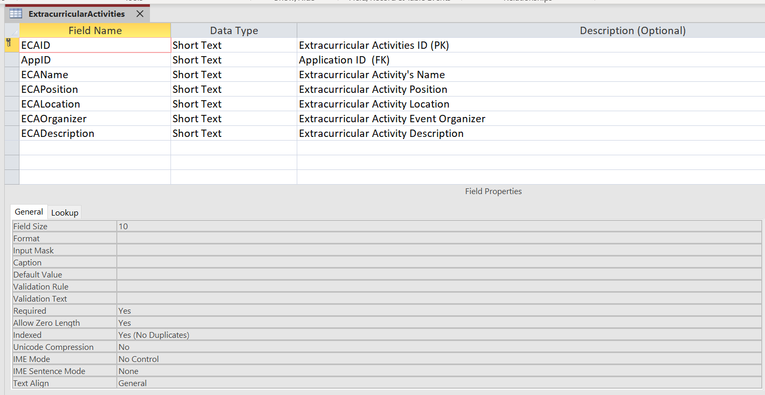

**Table Records**

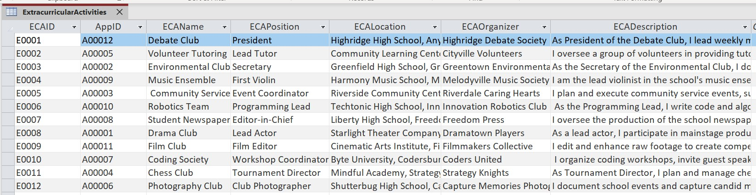

### Table 3.1.4: Recommendation

#### Data Dictionary

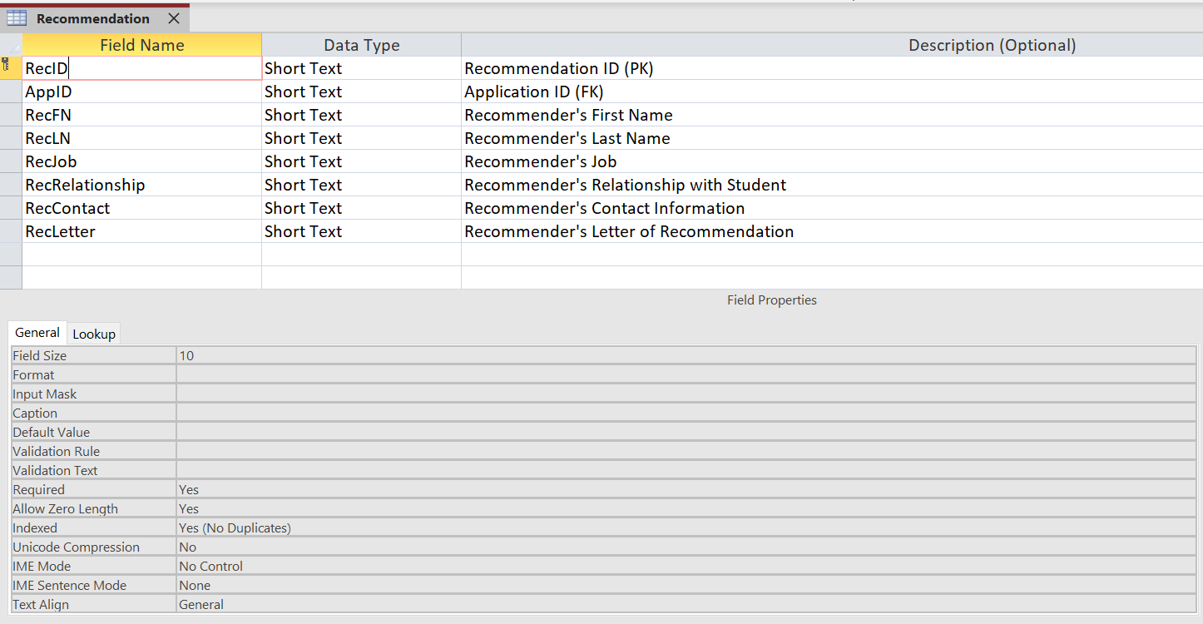

**Table Records**

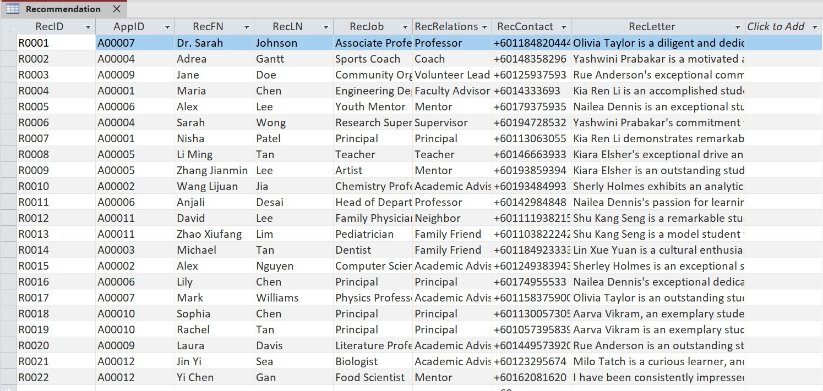

### Table 3.1.5: ScholarshipProvider

#### Data Dictionary

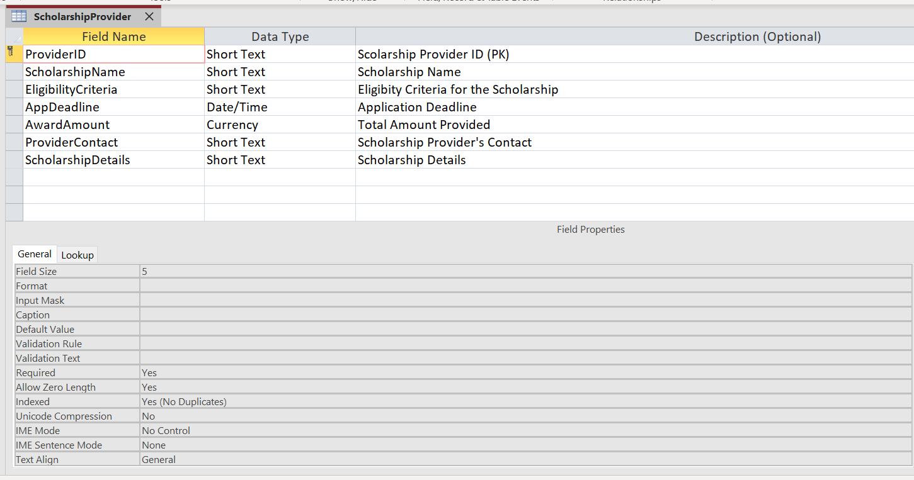

**Table Records**

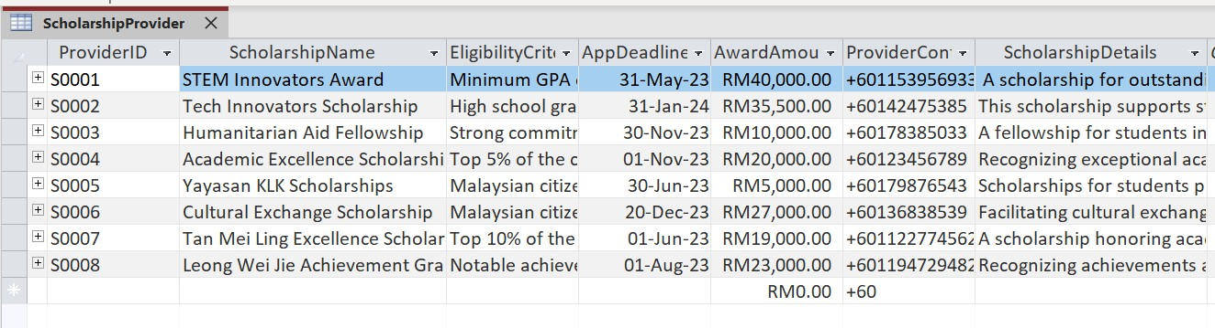

### Table 3.1.6: SpmResult

#### Data Dictionary

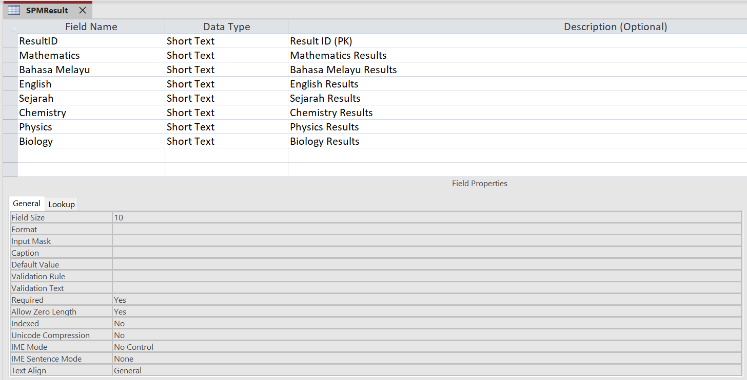

**Table Records**

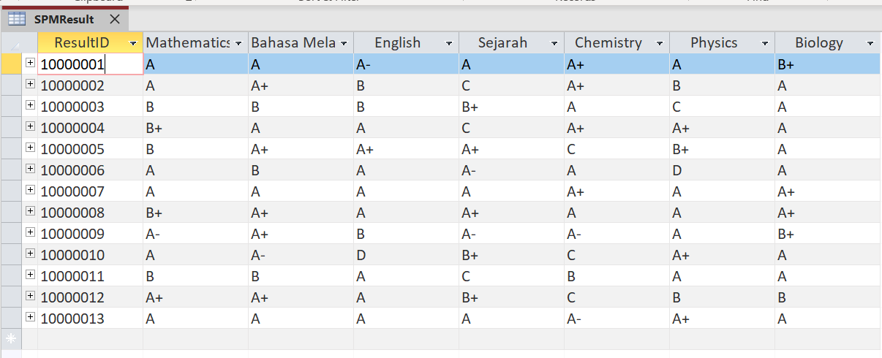

### Table 3.1.7: Student

#### Data Dictionary

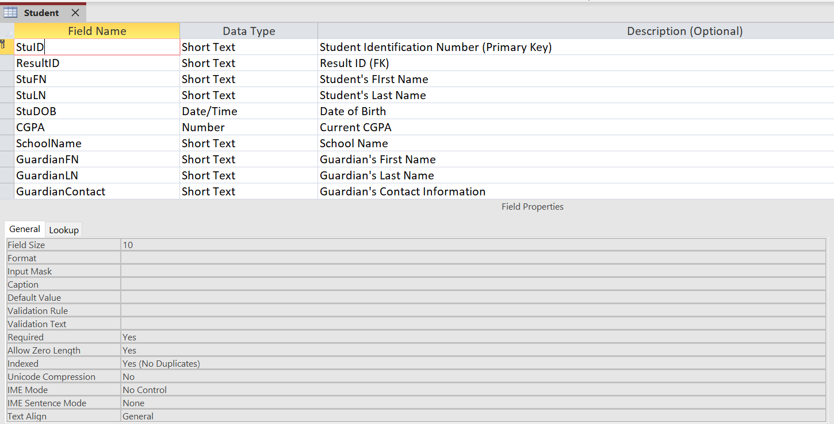

**Table Records**

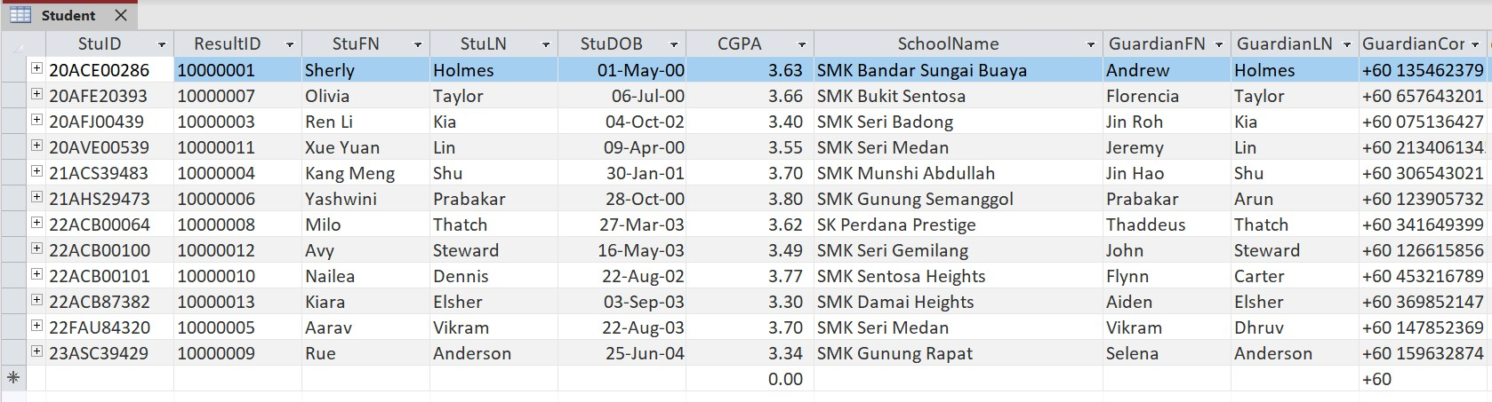

## Switchboard

In Microsoft Access, the switchboard is a user interface that allows users to access stored data like tables, queries, forms, and reports.

#### Main Menu

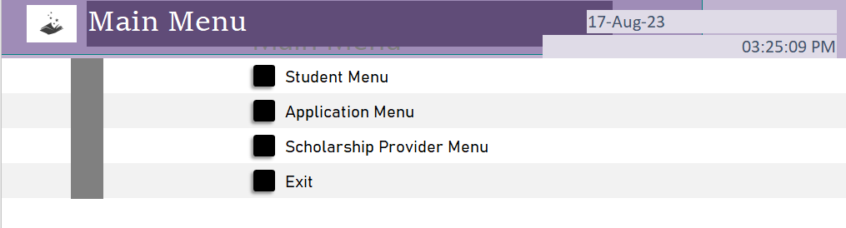

Figure 3.2.1

#### Student Menu

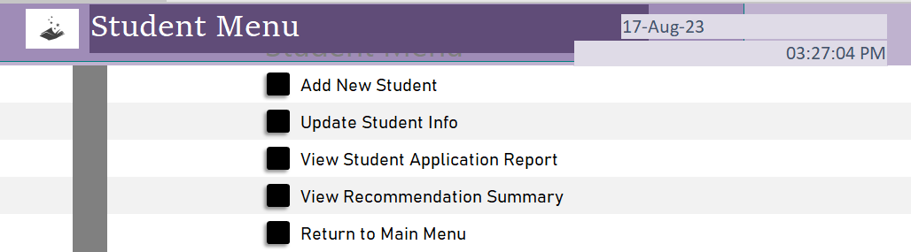

Figure 3.2.2

#### Scholarship Provider Menu

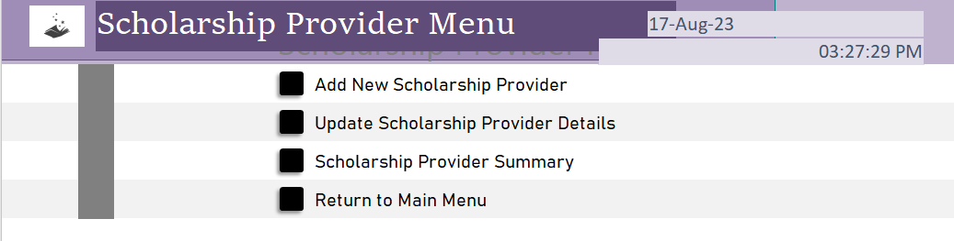

Figure 3.2.3

#### Application Menu

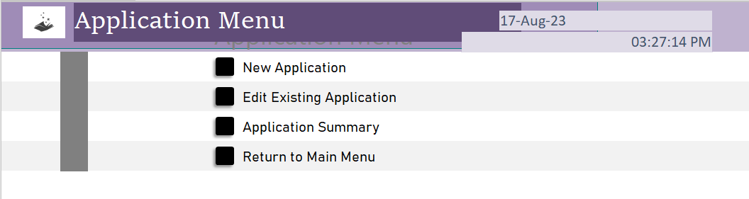

Figure 3.2.4

# Chapter 4 Database Objects

Database Objects refer to the fundamental components within a database management system (DBMS) that help organize, store, and manage data efficiently. These objects include entities such as tables, queries, forms, reports, indexes, and more. Each object serves a specific purpose of its own.

#### Queries

Queries in a database refer to requests for specific information or actions performed on the stored data using a query language like SQL (Standard Query Language). Queries are used to retrieve, manipulate, update, or delete data in a structured and efficient manner. They allow users to interact with the database without needing to know the underlying details of its organization.

#### Query 1

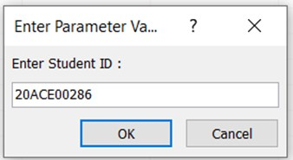



Figure 4.1.1: Sample of View AppStatus

#### Explanation:

The first query is ‘View Application Status’. This query will help students check on their application status. After entering their student ID, they will get a return of AppID, ProviderID, AppStatus, and AppDate. Each student will have a unique AppID when they are registered as an applicant.

#### SQL command:

SELECT StuID, AppID, ProviderID, AppStatus, AppDate FROM Application;

#### Query 2

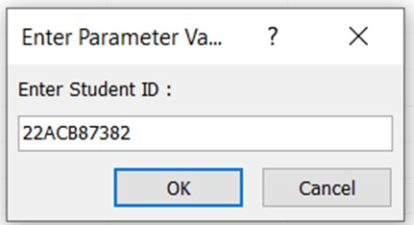

Figure 4.1.2: Sample of View Recommender query

#### Explanation:

The second query is ‘View Recommender’. In this query, students will have to enter their studentID and have a result of Student First Name, Student Last Name, CGPA, RecommenderID, Recommender First Name, Recommender Last Name and Recommendation Letter.

#### SQL command:

SELECT StuID, AppID, StuFN, StuLN, CGPA, RecID, RecFN, RecLN, RecLetter FROM Student s, Application a, Recommendation r

WHERE s.StuID = a.StuID AND a.AppID = r.AppID;

#### Query 3

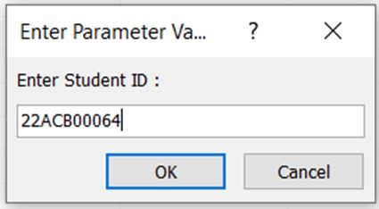

Figure 4.1.3: Sample of View Result Query

#### Explanation:

The third query is ‘View Result’. This query enables students to view their own SPM results containing Mathematics, Bahasa Melayu, English, Sejarah, and one of the Science Subjects using their StudentID.

#### SQL command:

SELECT StuID, ResultID, StuFN, StuLN, Mathematics, Bahasa Melayu, English, Sejarah, Chemistry

FROM Student JOIN SPMResult Using (StuID, ResultID);

#### Forms

Forms refer to user interfaces in a database context that provide a structured and user-friendly way to interact with the data stored in a database. These forms act as a bridge between users and the underlying database. Forms typically offer a more intuitive and visually organized way to handle data entry and retrieval.

#### Form 1

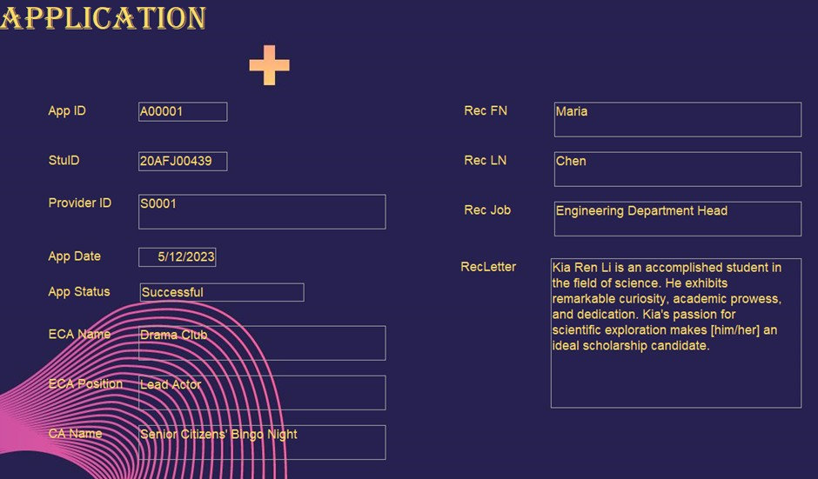

Figure 4.2.1: Sample of Application Form

#### Explanation:

The first form is the ‘Application’ form. This form will handle the scholarship application process. It will include various fields such as Student details, Application details, and Recommender details for better and less confusing viewing purposes.

#### Form 2

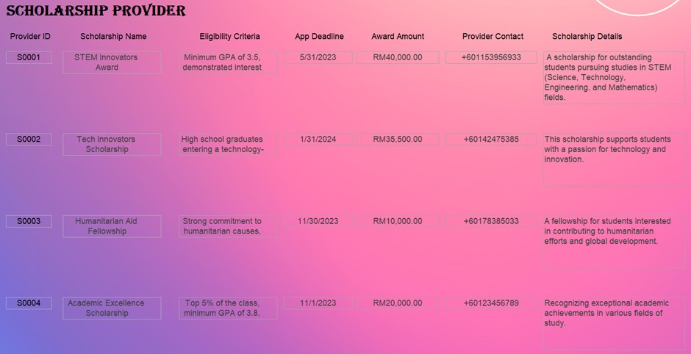

Figure 4.2.2: Sample of Scholarship Provider Form

#### Explanation:

The "Scholarship Provider" form is the second document. In order to reduce the need for students to search in numerous places, this form will store information about scholarship providers. In this form, they can find out everything they need to know about the scholarship they want. This form includes various fields such as Scholarship Name, Amount Awarded, Contact information, and Scholarship Description.

#### Form 3

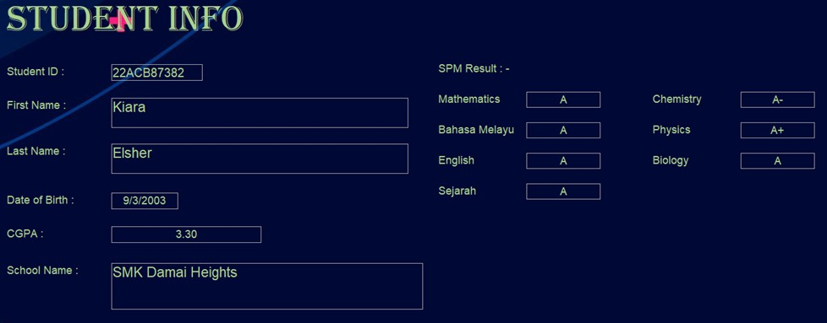

Figure 4.2.3: Sample of Student Info Form

#### Explanation:

The third form is the ‘Student Info’ form. This form will allow you to input and view details about the SPM graduates applying for scholarships. It includes fields such as student ID, student name, date of birth, CGPA, School name, and result.

#### Reports

In the context of databases, reports are structured presentations of data that provide organized and summarized information from the underlying database. Reports are designed to convey insights, trends, and important details in a comprehensible and visually appealing format. They allow users to understand complex data at a glance and make informed decisions.

#### Report 1

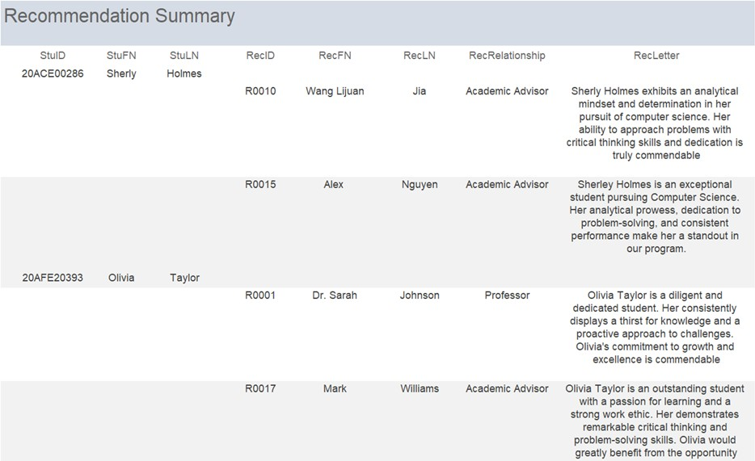

Figure 4.3.1: Sample of Recommendation Summary Report

#### Explanation:

The first report is the ‘Recommendation Summary’ report. This report summarizes the recommendations provided by the referees for each student’s application. It helps administrators evaluate the credibility of each application and understand the relationship between applicants and referees.

#### Report 2

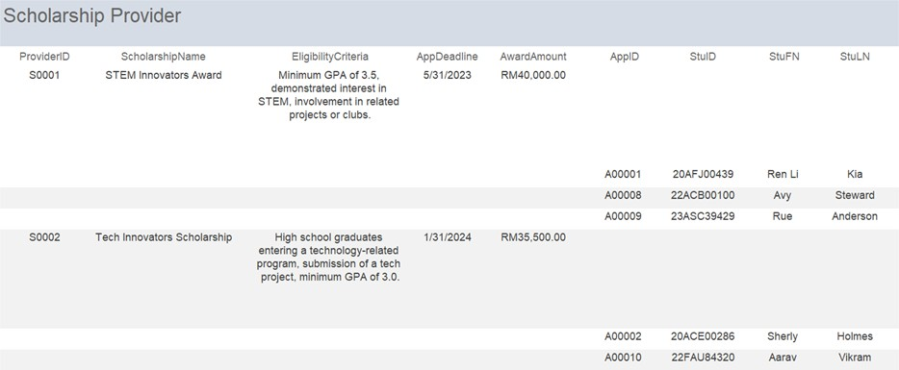

Figure 4.3.2: Sample of Scholarship Provider Report

#### Explanation:

The second report is ‘Scholarship Provider’ report. This report provides information about the scholarship providers and the applications associated with them. It helps administrators understand the distribution of applications across different scholarships and assess the popularity of each scholarship.

#### Report 3

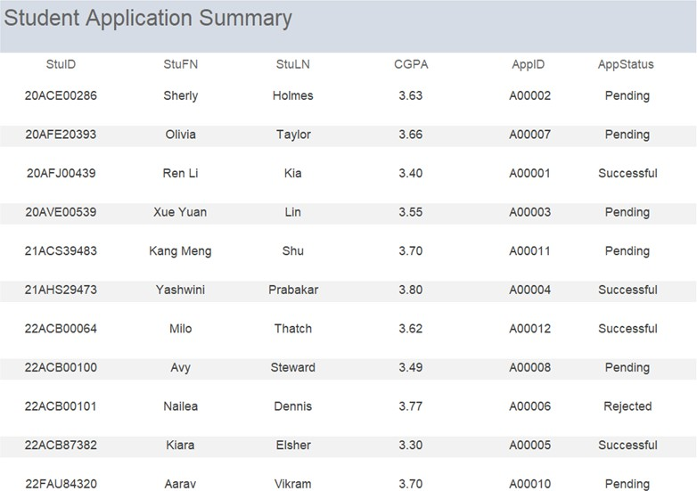

Figure 4.3.3: Sample of Student Application Summary

#### Explanation:

The third report is the ‘Student Application Summary’ report. This report provides an overview of each student’s scholarship application. It includes details such as the student’s personal information, SPM results, submitted applications, and their status. This report helps both students and administrators track application progress.

# Chapter 5 Conclusion

#### System Weakness

* + 1. The issue or flaw in this project stems from the system's lack of attributes and entities. This is due to the fact that more entities and attributes allow for more detailed relationships and easier user comprehension of the relationships. Examples of attributes that should be added to the student entity include the student's ID number, phone number, courses, and many more. Doing so will make the student's details more readable and imaginable.
    2. Important details, like the course chosen or whether they are SPM graduates, were missing. The scholarship provider was unable to locate that crucial information through the application as a result. As a result, crucial information about SPM graduates cannot be stored in the database. Additionally, this oversight leads to an incomplete representation of important data regarding SPM dropouts.
    3. The forms lack flexibility. This is because the forms are only available for users to see and check the details, while they are unable to change them directly on the forms. Hence, when the student’s details are wrongly filled in, they are unable to change the details in the forms.

#### Future improvements

* + 1. Through the planned extension of both attributes and entities, the system can reach a greater degree of functionality and usability. The complexity of relationships is highlighted by adding multiple relevant attributes to entities like the student entity, which eventually results in a more vivid and understandable depiction of the system's underlying data structures.
    2. By implementing attributes like CGPA and Course Decisions into the system, it is essential to overcome the lack of important information. This data becomes essential not only for scholarships but also for providing insights into academic trends and supporting efficient educational planning. This strategic improvement not only improves the entire dataset and provides scholarship sponsors with essential information, but it also allows for a more nuanced assessment of the academic paths and goals of SPM graduates.
    3. Several improvements can be implemented to our forms to improve their flexibility and address the issue of users being unable to change their information directly. First, by converting the forms into documents with editable features, we can enable users to fix mistakes. It is possible to add real-time validation to give immediate feedback on data input, reducing errors from the start. Individuals would be able to view and change their information when it is filled in, providing a smooth experience for updating the forms.